WEEKLY ASSIGNMENT - 1
Database Creation:
Create database salesDB;
use salesDB;
Tables Creation:
-- CREATE CLIENT TABLE
CREATE TABLE Client (
ClientNo VARCHAR(6) PRIMARY KEY,
Name VARCHAR(20) NOT NULL,
Address1 VARCHAR(30),
Address2 VARCHAR(30),
City VARCHAR(15),
PinCode NUMERIC(8),
State VARCHAR(15),
BalDue DECIMAL(10,2),
CHECK (ClientNo LIKE 'C%')
);
-- CREATE PRODUCT TABLE

CREATE TABLE Product (
ProductNo VARCHAR(6) PRIMARY KEY,
Description VARCHAR(15) NOT NULL,
ProfitPerc DECIMAL(4,2) NOT NULL,
UnitMeasure VARCHAR(10) NOT NULL,
QtyOnHand NUMERIC(8) NOT NULL,
ReorderLvl NUMERIC(8) NOT NULL,
SellPrice DECIMAL(8,2) NOT NULL,
CostPrice DECIMAL(8,2) NOT NULL,
CHECK (ProductNo LIKE 'P%'),
CHECK (SellPrice <> 0),
CHECK (CostPrice <> 0)
);
-- CREATE SALESMAN TABLE

CREATE TABLE Salesman (
SalesmanNo VARCHAR(6) PRIMARY KEY,
SalesmanName VARCHAR(20) NOT NULL,
Address1 VARCHAR(30) NOT NULL,
Address2 VARCHAR(30),
City VARCHAR(20),
PinCode NUMERIC(8),
State VARCHAR(20),
SalAmt DECIMAL(8,2) NOT NULL,
TgtToGet DECIMAL(6,2) NOT NULL,
YtdSales DECIMAL(6,2) NOT NULL,
Remarks VARCHAR(60),
CHECK (SalesmanNo LIKE 'S%'),
CHECK (SalAmt <> 0)
);
-- CREATE SALES ORDER TABLE

CREATE TABLE SalesOrder (
OrderNo VARCHAR(6) PRIMARY KEY,
ClientNo VARCHAR(6),
OrderDate DATE,
DelyAddr VARCHAR(25),
SalesmanNo VARCHAR(6),
DelyType CHAR(1),
BilledYN CHAR(1),
DelyDate DATE,
OrderStatus VARCHAR(20),
CHECK (OrderNo LIKE 'O%'),
CHECK (DelyType IN ('P','F')),
CHECK (BilledYN IN ('Y','N')),
CHECK (OrderStatus IN ('In Process','Fulfilled','Backorder','Cancelled')),
FOREIGN KEY (ClientNo) REFERENCES Client(ClientNo),
FOREIGN KEY (SalesmanNo) REFERENCES Salesman(SalesmanNo)
);
-- CREATE SALES ORDER DETAILS TABLE

CREATE TABLE SalesOrderDetails (
OrderNo VARCHAR(6),
ProductNo VARCHAR(6),
QtyOrdered NUMERIC(8),
QtyDisp NUMERIC(8),
ProductRate DECIMAL(10,2),
PRIMARY KEY (OrderNo, ProductNo),
FOREIGN KEY (OrderNo) REFERENCES SalesOrder(OrderNo),
FOREIGN KEY (ProductNo) REFERENCES Product(ProductNo)
);

Inserting Records:
-- INSERT RECORDS TO CLIENT TABLE
INSERT INTO Client VALUES
('C0001','Amit','MG Road','Andheri','Mumbai',400001,'Maharashtra',1200.50),
('C0002','Neha','Link Road','Bandra','Mumbai',400050,'Maharashtra',500.00),
('C0003','Rahul','Park Street','Salt Lake','Kolkata',700001,'West Bengal',0.00),
('C0004','Sneha','Ring Road','Indiranagar','Bangalore',560001,'Karnataka',800.75),
('C0005','Kiran','Main Street','Abids','Hyderabad',500001,'Telangana',300.00),
('C0006','Ivan Bayross','Hill Road','Bandra','Mumbai',400050,'Maharashtra',2500.00);
-- INSERT RECORDS TO PRODUCT TABLE
INSERT INTO Product VALUES
('P0001','1.44 drive',10.50,'Piece',100,20,1150.50,900),
('P0002','Trousers',15.00,'Piece',150,30,2500,2000),
('P0003','Pull Overs',12.00,'Piece',200,40,1800,1200),
('P0004','Monitor',20.00,'Piece',80,15,5200,4500),
('P0005','Printer',18.00,'Piece',60,10,6000,5000);
-- INSERT RECORDS TO SALESMAN TABLE
INSERT INTO Salesman VALUES
('S0001','Aman','Park Ave','Ameerpet','Hyderabad',500016,'Telangana',25000,100,50,'Good'),
('S0002','Anil','Main Road','Banjara Hills','Hyderabad',500034,'Telangana',22000,120,4500,'Excellent'),
('S0003','Meena','MG Road','Brigade','Bangalore',560025,'Karnataka',18000,90,3000,'Average');
-- INSERT RECORDS TO SALES ORDER TABLE
INSERT INTO SalesOrder VALUES
('O19001','C0001','2002-04-10','Mumbai','S0001','P','Y','2026-01-04','Fulfilled'),
('O19002','C0002','2024-01-12','Mumbai','S0002','F','N','2024-01-18','In Process'),
('O19003','C0003','2024-01-20','Bangalore','S0003','P','Y','2024-01-25','Fulfilled'),
('O19004','C0006','2026-01-05','Mumbai','S0001','P','Y','2026-01-15','Fulfilled');
-- INSERT RECORDS TO SALES ORDER DETAILS TABLE
INSERT INTO SalesOrderDetails VALUES
('O19001','P0001',10,8,1200.00),
('O19001','P0002',5,5,2500.00),
('O19002','P0001',2,2,1200.00),
('O19002','P0003',3,10,1800.00),
('O19003','P0004',6,6,5200.00),
('O19003','P0005',3,2,6000.00),
('O19004','P0001',2,2,1200.00),
('O19004','P0002',1,1,2500.00);
Answer following queries with the help of above schema:
-- 1. Display the names of all the clients.

select Name from Client;
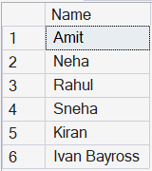

-- 2. Display all the clients who are located in Mumbai.

select * from Client where City='Mumbai';
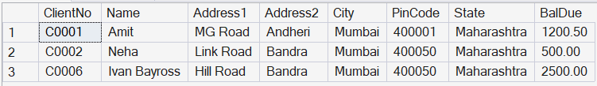

-- 3. Display all the products whose selling price is > 2000 and < 5000.

select * from Product where SellPrice between 2000 and 5000;

-- 4. Display Name, City and State of Clients not in the state of Maharashtra.

select Name,City,State from Client where state not in ('Maharashtra');
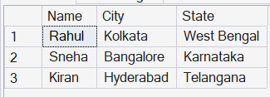
-- 5. Display all the information of client no C0001 and C0002.

select * from Client where ClientNo='C0001' or ClientNo='C0002';
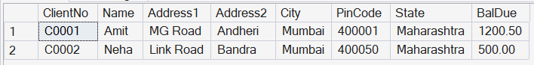
-- 6. Change the selling price of '1.44 drive' to Rs. 1150.50.

update Product
set SellPrice=1150.50 where Description='1.44 drive';

-- 7. Delete the record of client no C0005.
delete from Client where ClientNo ='C0005';

-- 8. Display the clients who stay in a city whose second letter is 'a'.

select * from Client where City like'_a%';

-- 9. Count the number of products having price greater than or equal to 1500.

select count(*) as no_of_products from Product where SellPrice>=1500;
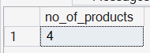

-- 10. Display qtyordered, qtydisp and balanceqty (not in table).

select s.QtyOrdered,s.QtyDisp,p.QtyOnHand as balanceQty from
SalesOrderDetails as s join product as p
on s.ProductNo=p.ProductNo;
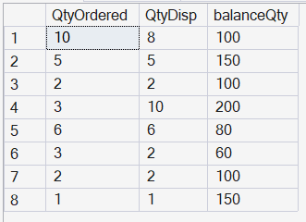
Write Commands to do Following:
-- 1. Make Client_no as primary key in client_master.

ALTER TABLE Client
ADD CONSTRAINT PK_Client PRIMARY KEY (ClientNo);

-- 2. Add a new column phone_no in the client_master table.

ALTER TABLE Client
ADD PhoneNo VARCHAR(15);

-- 3. Add the not null constraint in the product_master table with the column description, profit percent, sell price and cost price.
ALTER TABLE Product
ALTER COLUMN Description VARCHAR(15) NOT NULL;

ALTER TABLE Product
ALTER COLUMN ProfitPerc DECIMAL(5,2) NOT NULL;

ALTER TABLE Product
ALTER COLUMN SellPrice DECIMAL(8,2) NOT NULL;

ALTER TABLE Product
ALTER COLUMN CostPrice DECIMAL(8,2) NOT NULL;

-- 4. Change size of name column to 60 in client_master table.
ALTER TABLE Client
ALTER COLUMN Name varchar(60);

-- 5. Remove pincode column from table.
ALTER TABLE Client
DROP COLUMN PinCode;
Define in 1 or 2 lines and give one example also:
1. Recursive Relationship
A recursive relationship is when a table is related to itself.
Example: In a Salesman table, if a salesman is supervised by another salesman in the same table, it forms a recursive relationship.
2. Composite Key
A composite key is a primary key made using two or more columns together.
Example: (OrderNo, ProductNo) in the SalesOrderDetails table.

3. The LIKE Operator with Pattern Matching
The LIKE operator is used to search for a specific pattern in a column.
Example: select * from Client where City like 'M%';
4. DROP TABLE Command
The DROP TABLE command is used to permanently remove a table from the database.
Example: drop table Product;
5. FULL OUTER JOIN
A FULL OUTER JOIN returns all rows from both tables whether a match exists or not.
Example:
select Client.ClientNo, SalesOrder.OrderNo
from Client
full outer join SalesOrder
on Client.ClientNo = SalesOrder.ClientNo;
-- WRITE QUERIES FOR FOLLOWING DESCRIPTIONS: (Joins)

-- 1. Find out the products which have been sold to 'Ivan Bayross'.
select distinct p.productno, p.description from client c
join salesorder s
on c.clientno = s.clientno
join salesorderdetails sd
on s.orderno = sd.orderno
join product p
on sd.productno = p.productno
where c.name = 'Ivan Bayross';
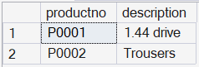
-- 2. Finding out the products and their quantities that will have to be delivered in the current month.

select
p.productno,
p.description,
sd.qtyordered
from salesorder s
join salesorderdetails sd
on s.orderno = sd.orderno
join product p
on sd.productno = p.productno
where month(s.delydate) = month(getdate()) and year(s.delydate) = year(getdate());
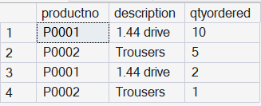

-- 3. Listing the ProductNo and description of constantly sold (i.e. rapidly moving) products.
select p.productno, p.description
from product p
join salesorderdetails sd on p.productno = sd.productno
group by p.productno, p.description
having count(distinct sd.orderno) > 1;
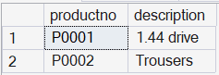
-- 4. Finding the names of clients who have purchased 'Trousers'.
select distinct c.clientno, c.name from client c
join salesorder s
on c.clientno = s.clientno
join salesorderdetails sd
on s.orderno = sd.orderno
join product p
on sd.productno = p.productno
where p.description = 'Trousers';
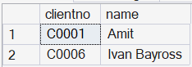

-- 5. Listing the products and orders from customers who have ordered less than 5 units of 'Pull Overs'.
select
s.orderno,
c.name as client_name,
p.productno,
p.description,
sd.qtyordered
from client c
join salesorder s
on c.clientno = s.clientno
join salesorderdetails sd
on s.orderno = sd.orderno
join product p
on sd.productno = p.productno
where p.description = 'Pull Overs'and sd.qtyordered < 5;
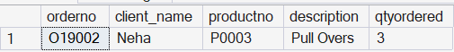
-- WRITE QUERIES FOR FOLLOWING DESCRIPTIONS: (Subqueries)

-- 1. Finding the non-moving products i.e. products not being sold.

select * from product
where productno not in (
select distinct productno from salesorderdetails);

-- 2. Finding the name and complete address for the customer who has placed Order number 'O19001'.

select name, address1, address2, city, pincode, state
from client
where clientno =(
select clientno from salesorder where orderno = 'O19001');
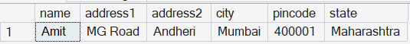

-- 3. Finding the clients who have placed orders before the month of May '02.

select * from client where clientno in (
select clientno from salesorder
where orderdate < '2002-05-01');
-- WRITE COMMANDS TO DO FOLLOWING

-- 1. Display system date as Saturday, February 11, 2012.

select format(cast('2012-02-11' as date), 'dddd, MMMM dd, yyyy') as SystemDate;
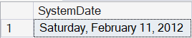

-- 2. Display Balance Due from Client master as $99,999.99.

select name, format(baldue, '$99,999.99') as BalanceDue from client;
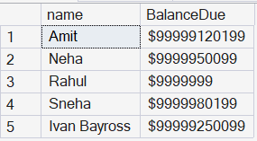
-- 3. Display message as 'Salesman Aman sold goods of 50 while given target was 100'.

select
'Salesman ' + SalesmanName +
'sold goods of ' + cast(YtdSales as varchar) +
' while given target was ' + cast(TgtToGet as varchar) as Message
from Salesman where SalesmanName = 'Aman';
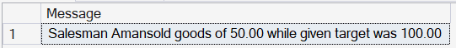
-- 4. Display your Age in Years.

select datediff(year, '2005-03-20', getdate()) as AgeInYears;
